 COSC 3380
Name: __Thanh Vo_________ Seat #D9

Project 1:
(100 points)
(Due date found in the COSC 3380 BB Calendar!)

1.a 0 points
1.b 30 points
1.c 10 points
1.d 10 points
2. 20 points
3. 30 points

PLEASE ENTER YOUR GRADE IN THIS BOX & ALSO on the CHECK SHEET:

1. (50 points)

(Please do not turn in these lines in yellow.)

(Please do not change the attribute names.)

(Please do not change file names.)

a. (0 points – separate document) Using the above COSC3380 Data Requirements create the ERD Model (must fit on one page)
(Conceptual Model – What - Analysis).

(Just place the ERD Diagram HERE)
A1: cus_id
A2: cus_name
A3: cus_address

A4: cus_city

E1: Customer
R4: DoBusiness
A5: cus_state
A9: cus_pass
A6: cus_postalcode

A7: cus_email
A1: ter_id
E5: SaleTerritory

A8: cus_username
R1: Submit

A2: ter_name

R5: ServedBy
A1: order_id

A1: per_id
E6: SalePerson
E2: Order
A2: per_name
A2: order_date
A6: per_pass

A3: per_tel
A5: per_user
A4: per_email
R2: OrderLine

A1: quantity

A1: prod_id
E3: Product

A2: price

A2: prod_name
R3: Group
A3: prod_finish
A4: prod_stdprice

A5: prod_photo
E4: ProductLine

A1: prup_id
A2: prodline_name
A1: prodline_id
E7: PriceUpdate

A2: prup_productname
A5: prup_newprice

A3: prup_changedate
A4: prup_oldprice

b. (30 points) COSC3380 Relational Model (must fit on one page)
(Internal Model – How - Design).
#Relations/Tables: _7__
E7: PriceUpdate

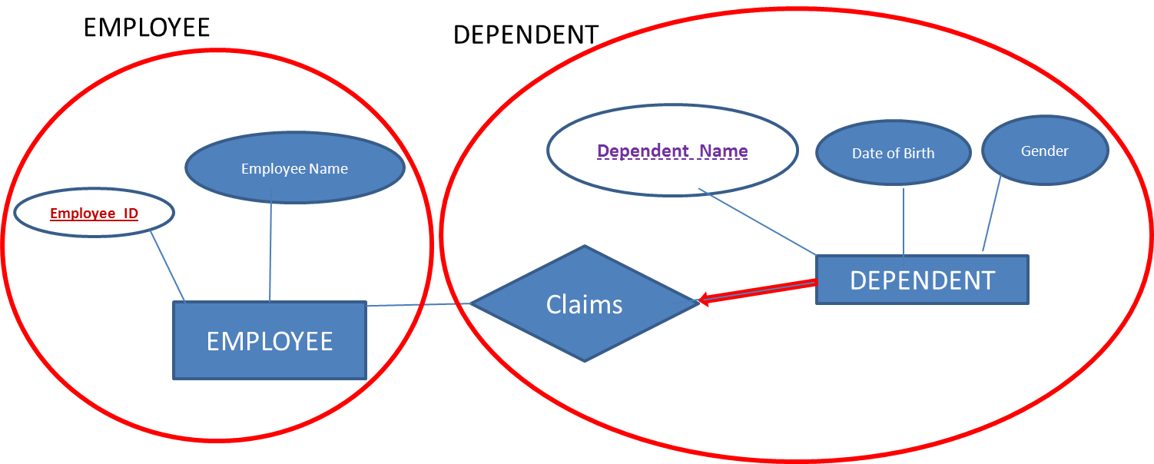
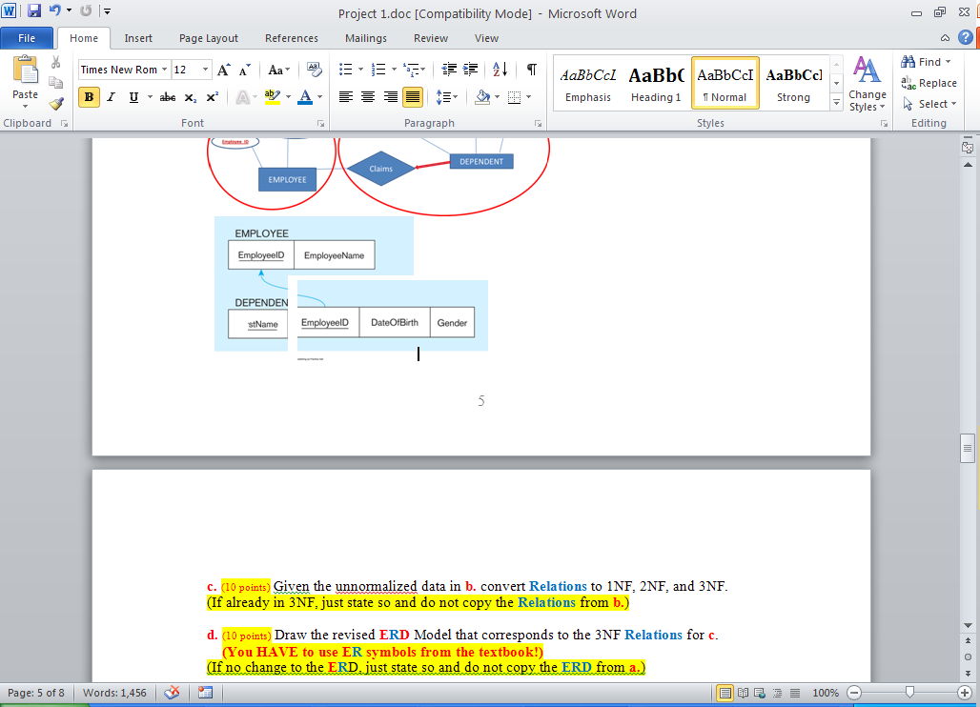

Customer

A1: cus_id
A3: cus_address
A2: cus_name
DoBusiness
A4: cus_city

E1: Customer
A5: cus_state
R4: DoBusiness

A6: cus_postalcode
A9: cus_pass
SaleTerritory
A1: ter_id

A7: cus_email
E5: SaleTerritory
A2: ter_name
Order
A8: cus_username
SalePerson
R1: Submit

R5: ServedBy

A1: order_id
A6: per_pass
A1: per_id
E2: Order

E6: SalePerson
A2: order_date
A5: per_user

A2: per_name
OrderLine
A4: per_email
A3: per_tel
R2: OrderLine

A1: quantity

A2: price

A1: prod_id
E3: Product

A2: prod_name
R3: Group
A3: prod_finish
A4: prod_stdprice
A1: prodline_id

A5: prod_photo
E4: ProductLine

Product
A2: prodline_name

E7: PriceUpdate

A1: prup_id
ProductLine
A5: prup_newprice

A2: prup_productname
A3: prup_changedate
A4: prup_oldprice
PriceUpdate

Customer

cus_id | cus_name | cus_address | cus_city | cus_state | cus_postalcode | cus_email | cus_username | cus_pass

Order
order_id | cus_id | order_date

OrderLine

order_id | prod_id | quantity | price

Product

prod_id | prodline_id | prod_name | prod_finish | prod_stdprice | prod_photo

ProductLine

prodline_id | prodline_name

DoBusiness

cus_id | ter_id

SaleTerritory

ter_id | ter_name

SalePerson

per_id | ter_id | per_name | per_tel | per_email | per_user | per_pass

PriceUpdate
prup_id | prup_productname | prup_changedate | prup_oldprice | prup_newprice

c. (10 points) Given the unnormalized data in b. convert Relations to 1NF, 2NF, and 3NF.
(If already in 3NF, just state so and do not copy the Relations from b.)

The relations are already in 1NF, 2NF and 3NF

d. (10 points) Draw the revised ERD Model that corresponds to the 3NF Relations for c.
(You HAVE to use ER symbols from the textbook!)
(If no change to the ERD, just state so and do not copy the ERD from a.)

There is no change to the ERD

2. (20 points)
Using SQL*Plus (Oracle DBMS) create the 3NF Tables from complete Project1 specified in 1. Display the structure for each Table after you created it. Make sure you implement all the necessary integrity constraints. SQL comment the SQL code. Turn in screenshots of each SQL command (SQL COMMENTS ARE A MUST) and its output as Project1.doc. SQL code needs to also be submitted to BB as Project1.sql.
9 RELATIONS:
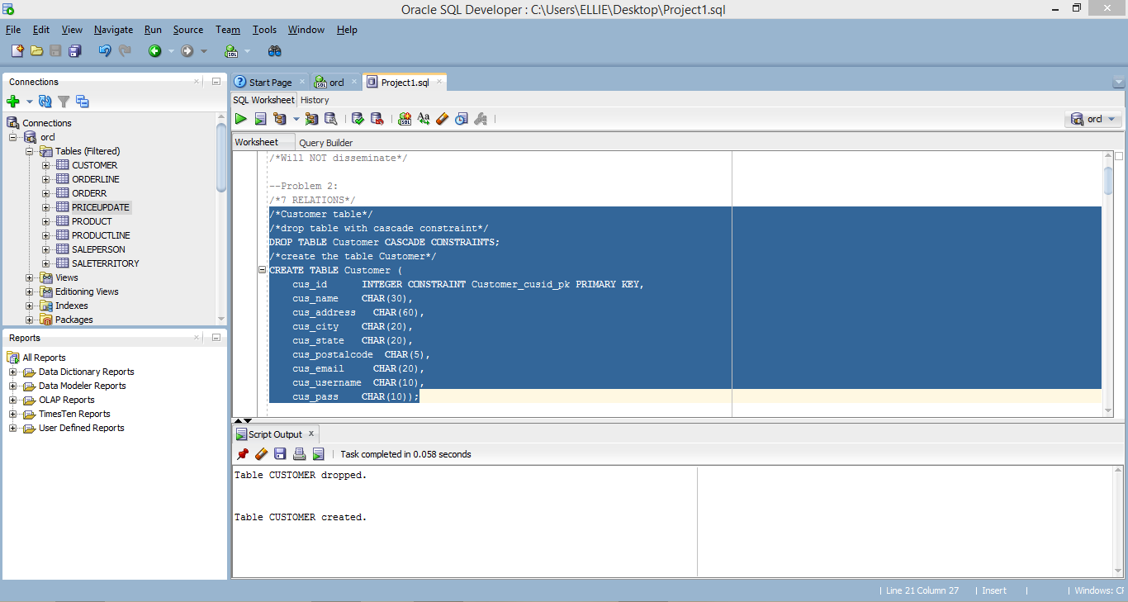
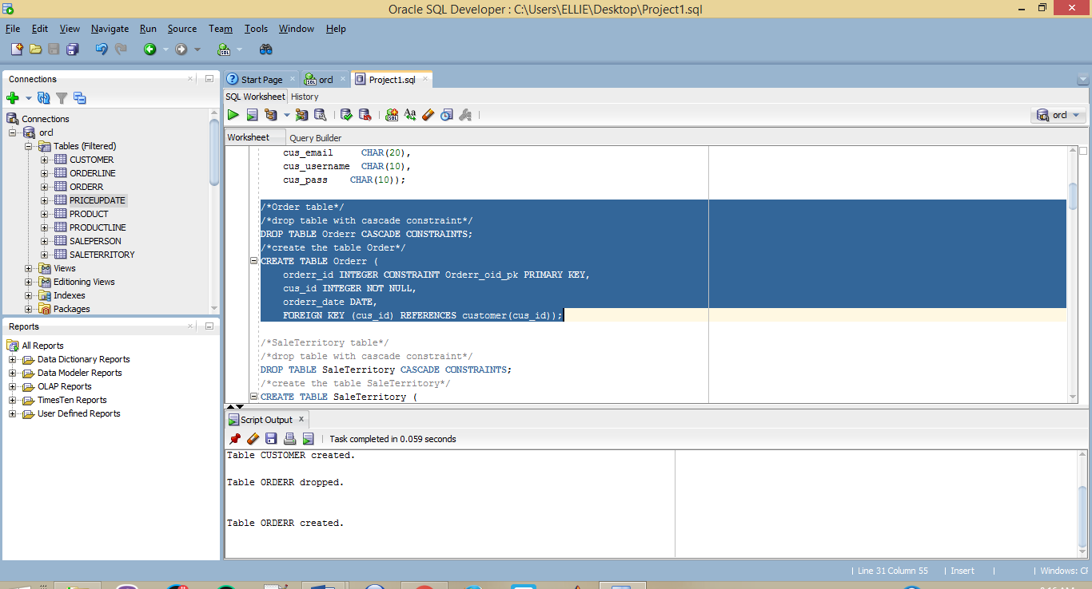
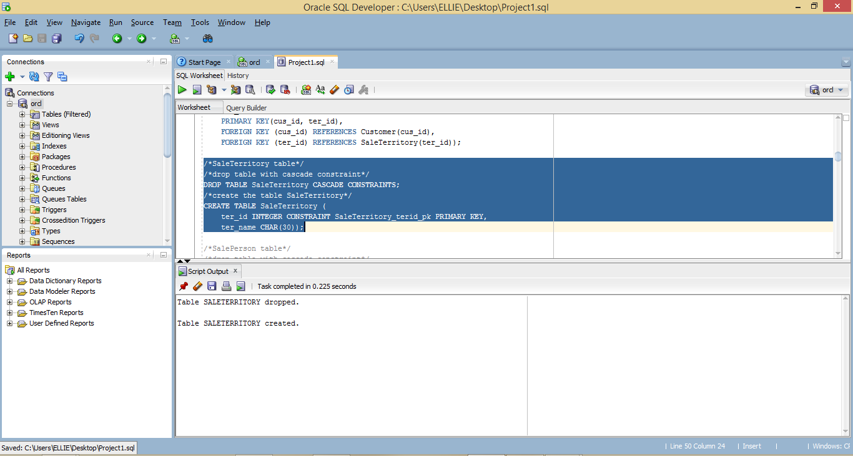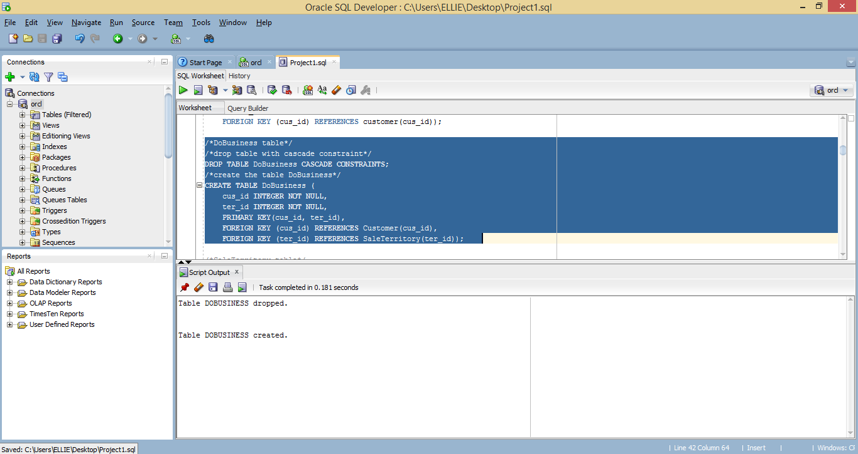
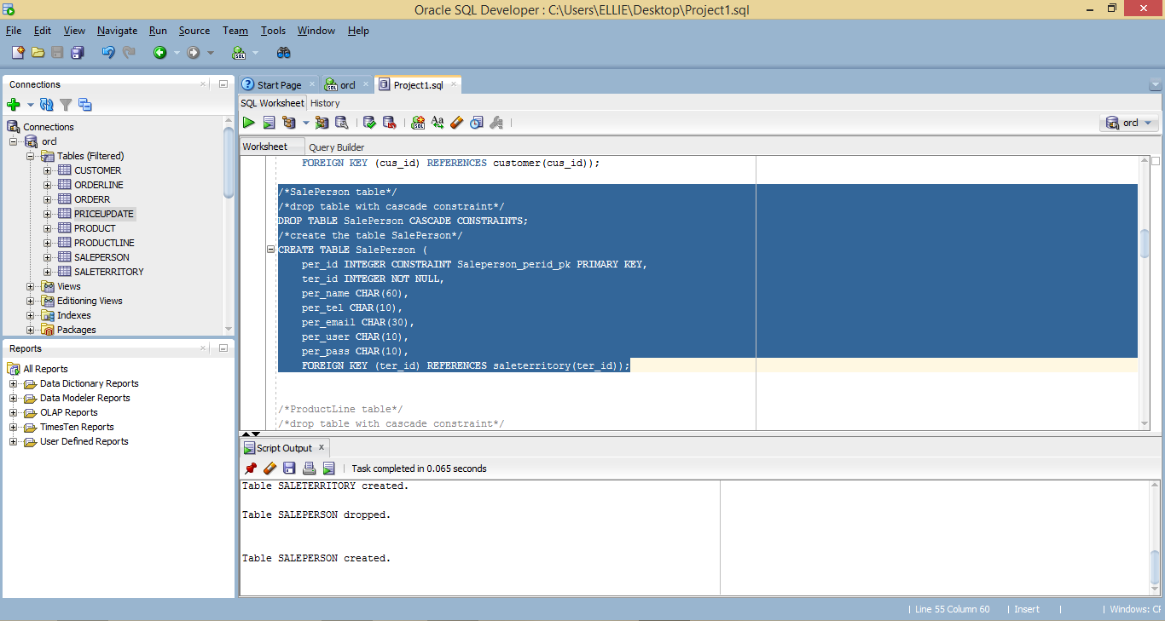
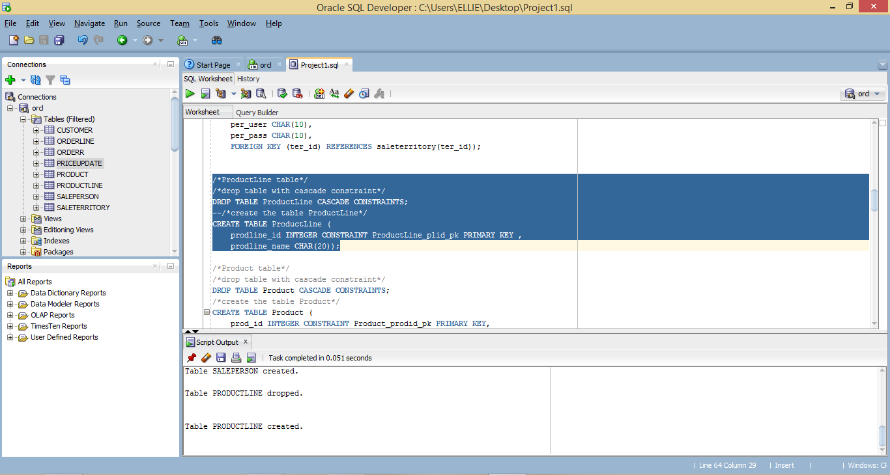
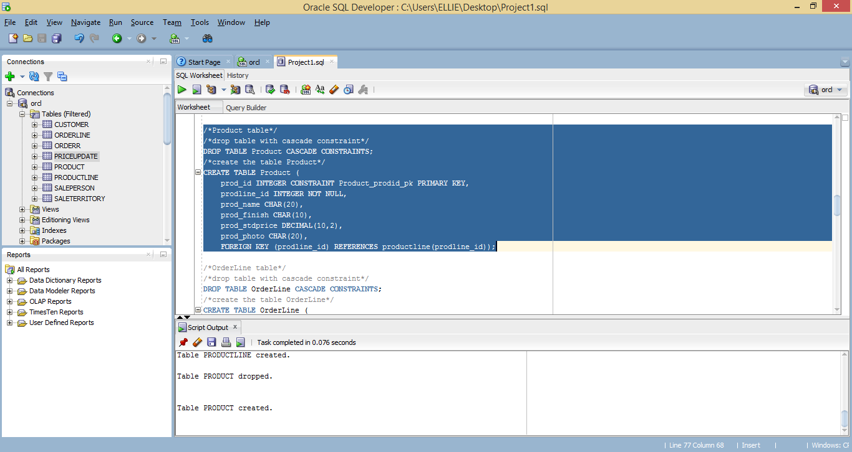
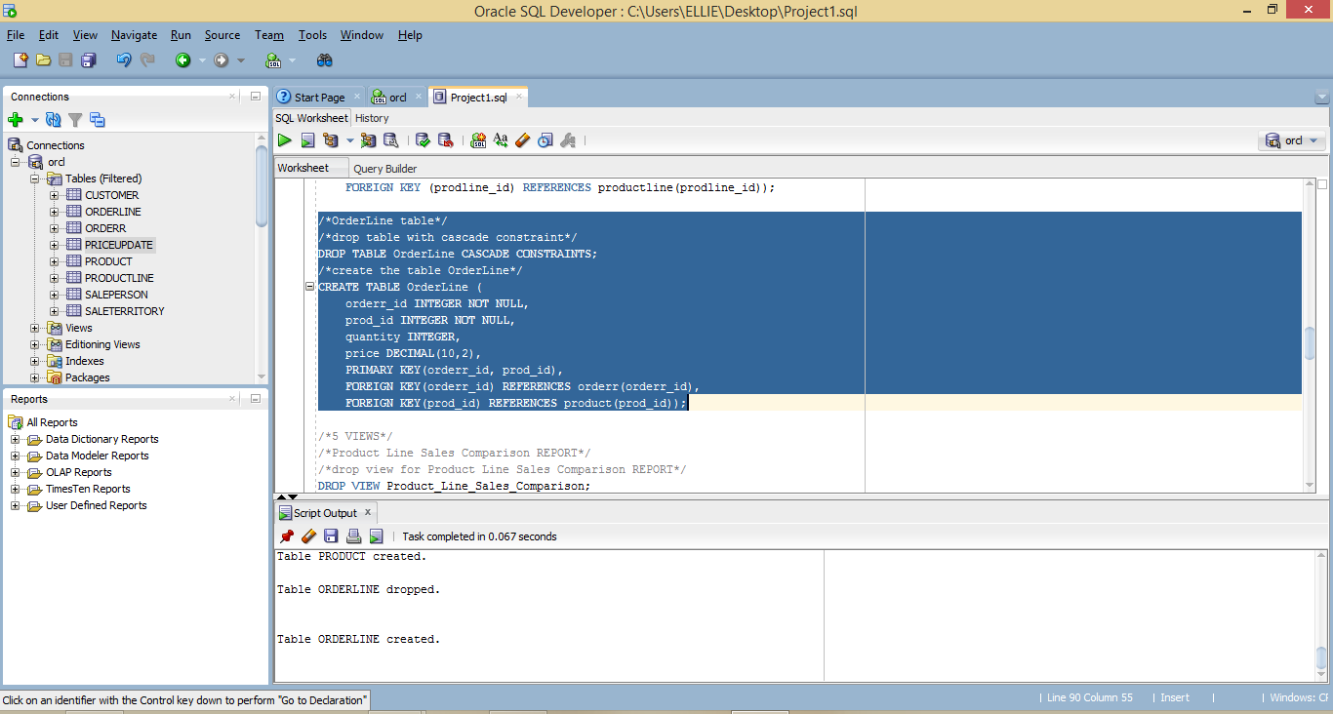
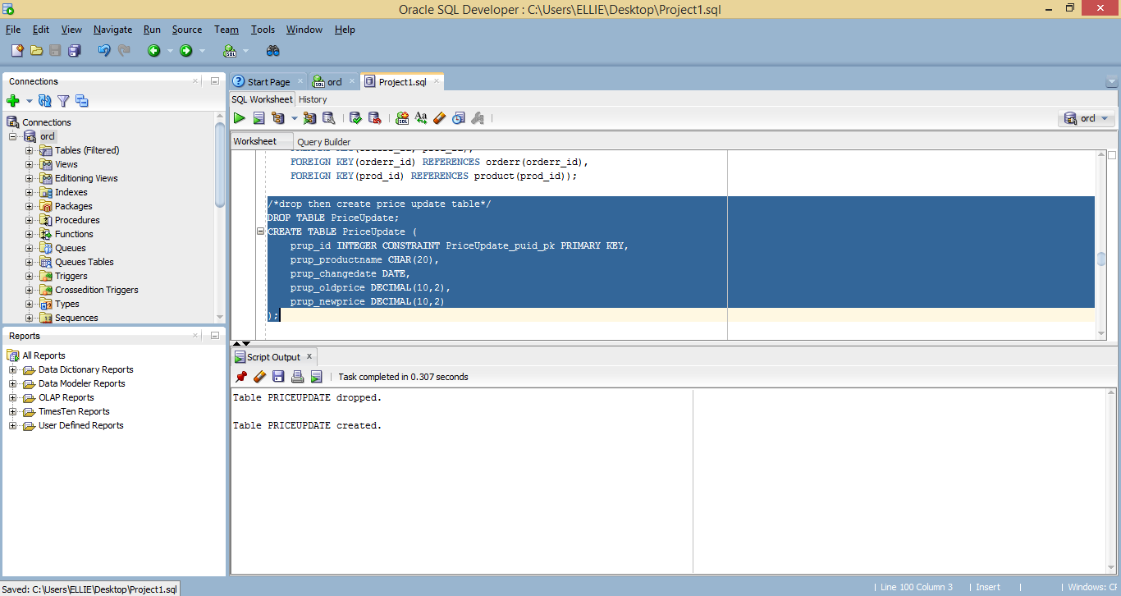
6 VIEWS
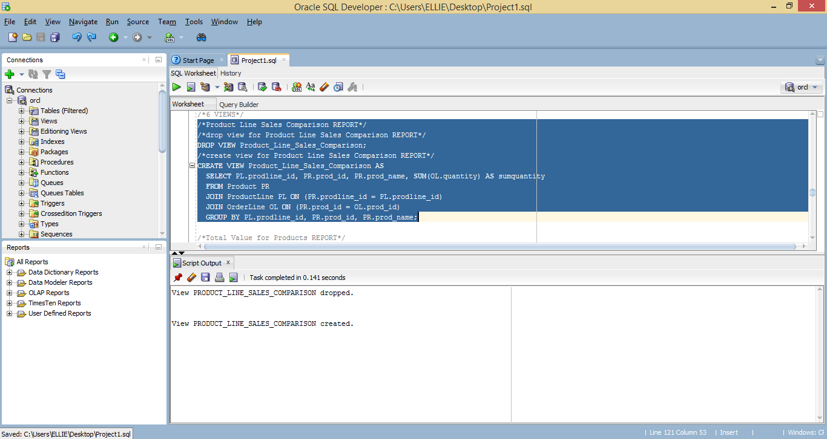
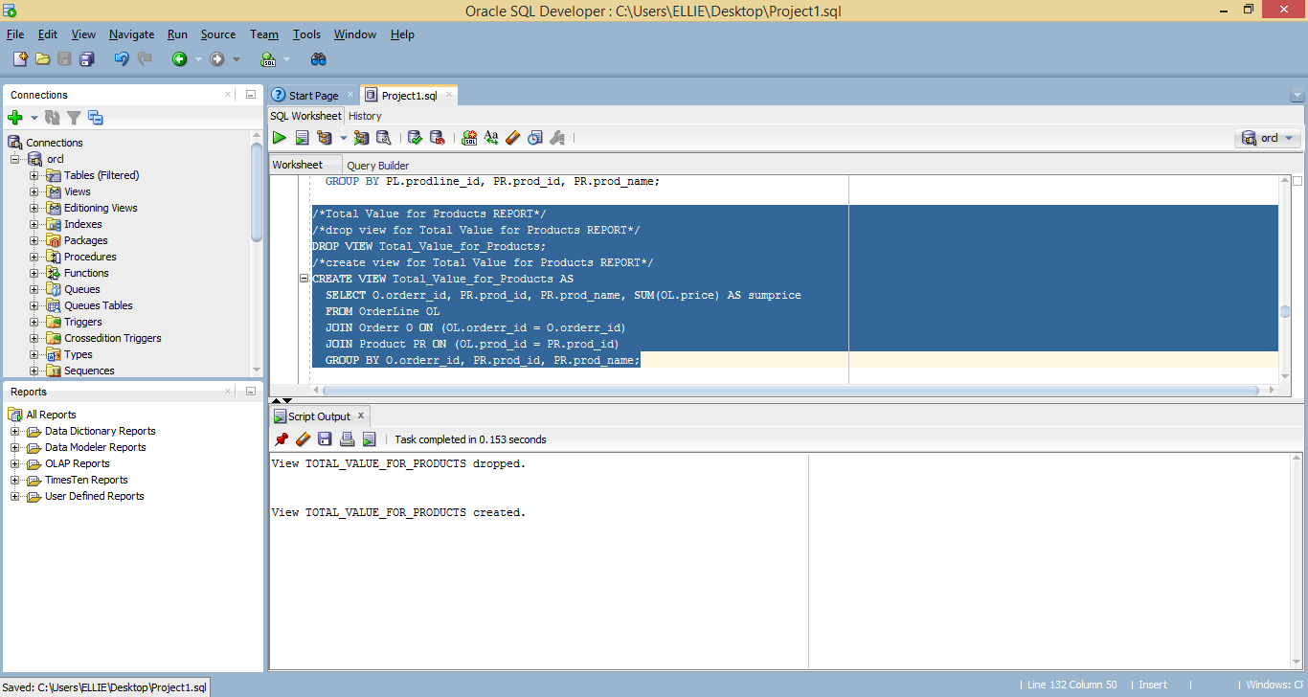
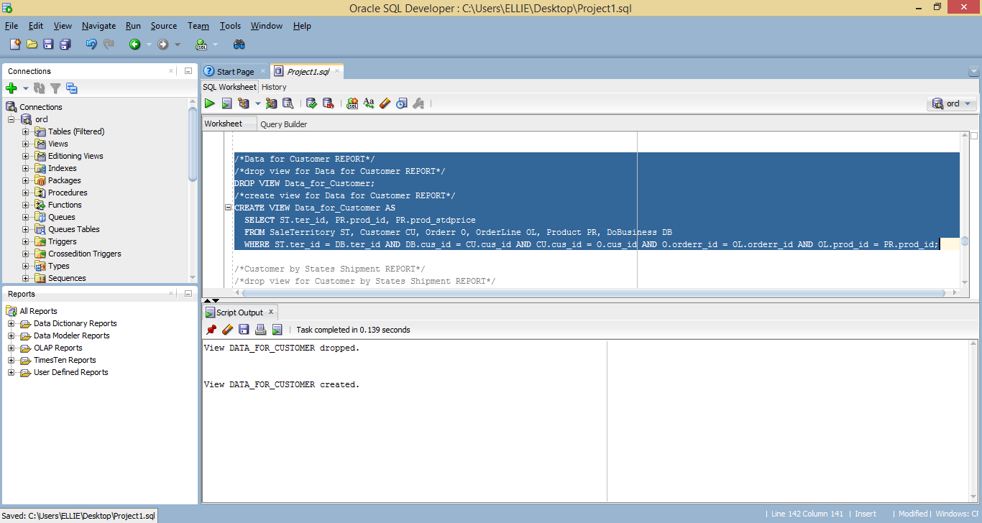
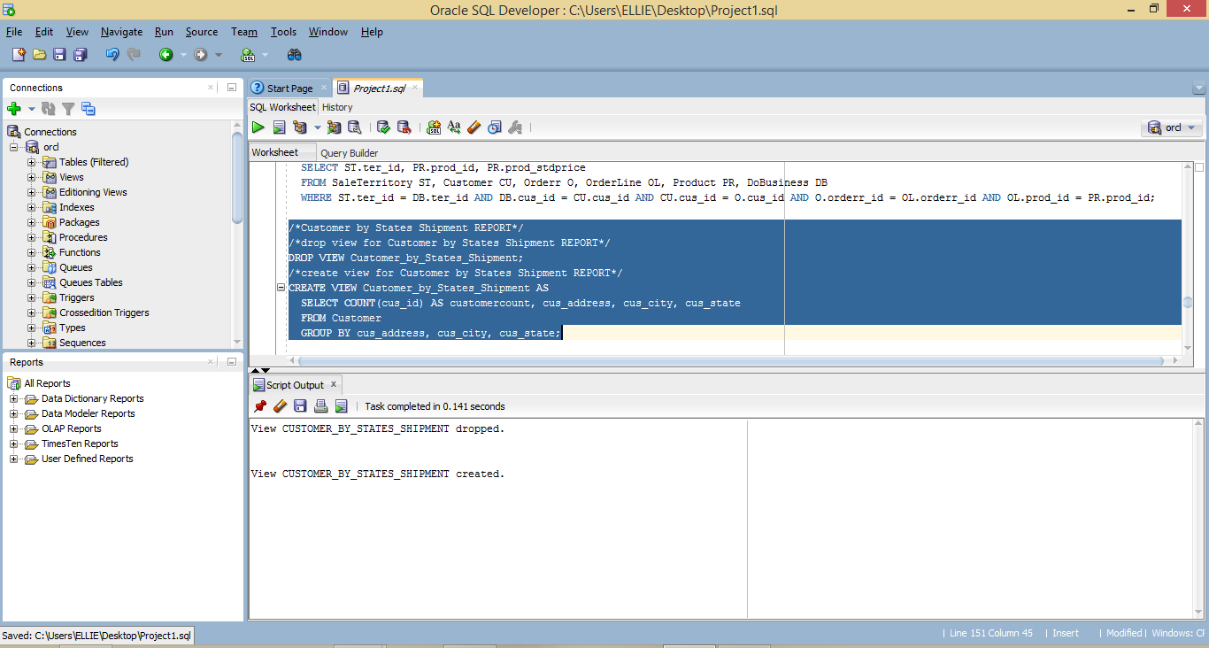
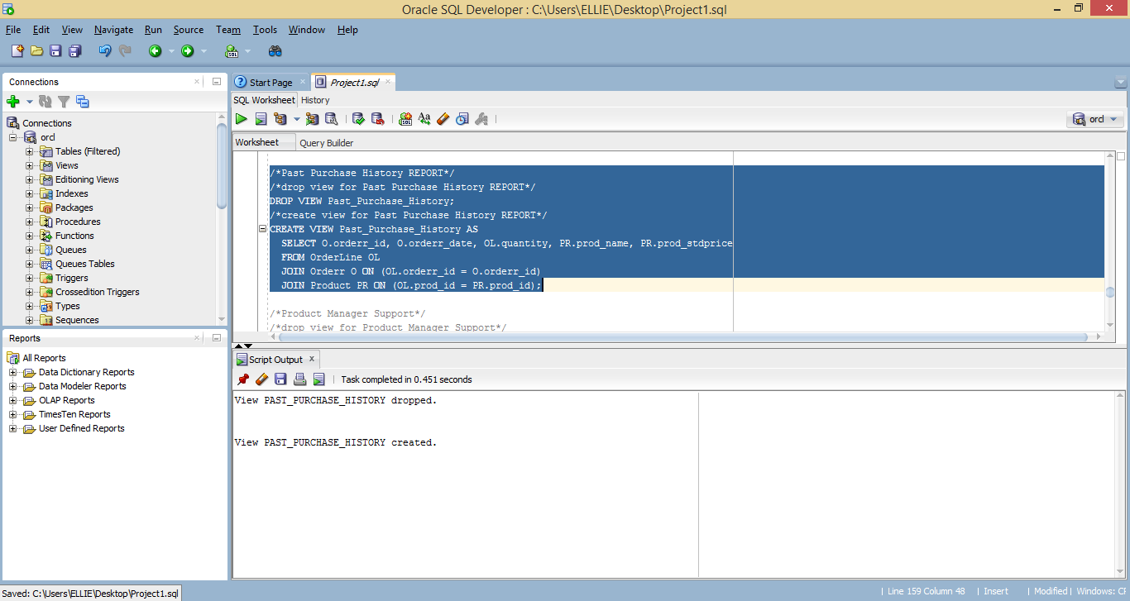
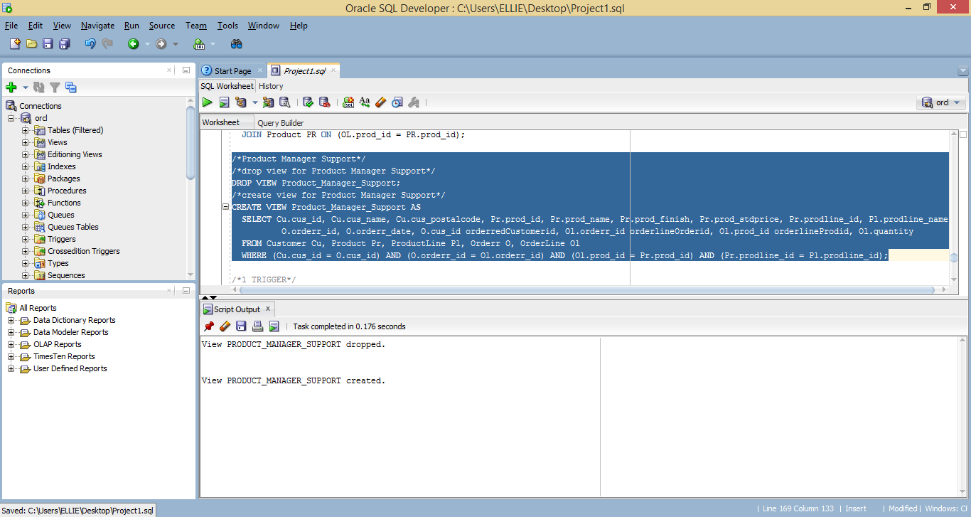
1 TRIGGER
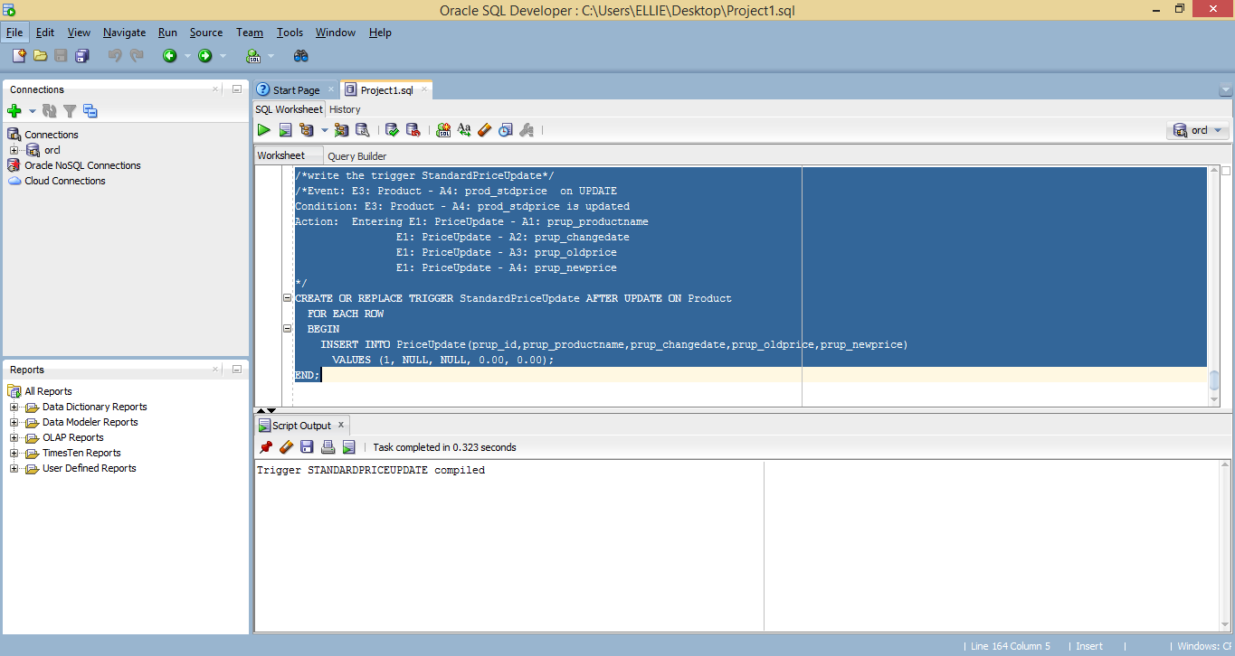

3. (30 points)
Create the COSC3380 Database tables in Microsoft Access DBMS (as Project1ACCESS) or Microsoft SQL Server 2008 DBMS (as Project1MSSQL) (available in the Computer Science LABS). Then request the Table Relationships Diagram for the Database. This will show you a visual representation of the COSC3380 Database. Turn in a screenshot of it. SQL code needs to also be submitted to BB as Project1ACCESS.sql or Project1MSSQL.sql.

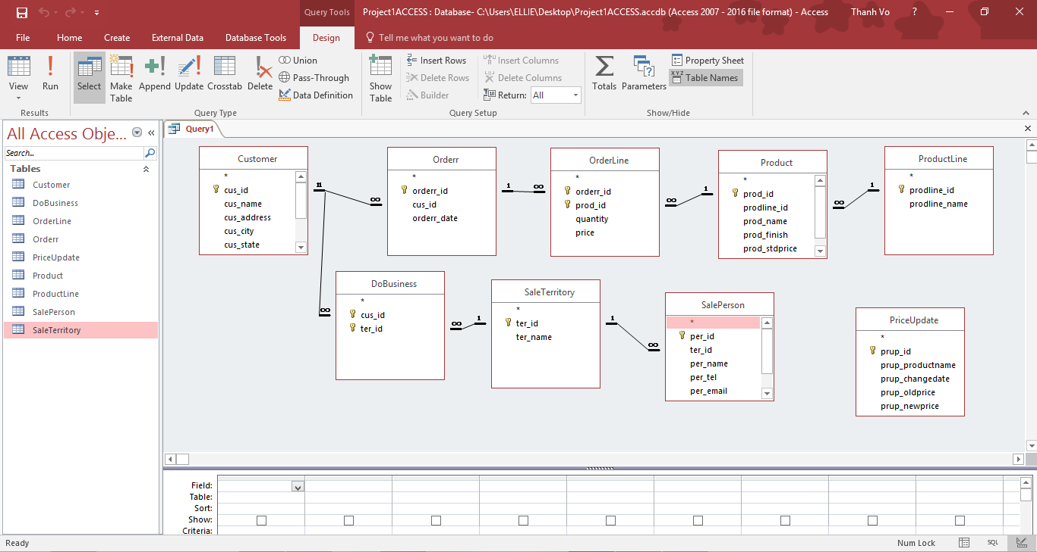

9 TABLES
